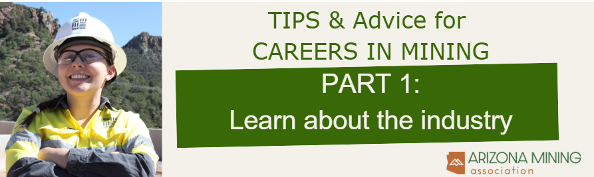

Imagine waking up to fresh air, ready for a day of challenges, camaraderie, and making the building blocks of life. Mining offers freedom, global impact, and a sense of purpose, with steady pay, benefits, and outdoor work. Join a community that shows up, rain or shine, ensuring the world keeps turning. If you're seeking adventure and meaningful work, mining awaits. Check out more at AZMining.org/Careers

Be curious about the industry. Knowing about the industry will help you customize your resume and stand out in an interview! Here are some thought starters for research.

- What is being mined in Arizona?
- What are these minerals used for?
- What is important to the industry? (Hint: safety is #1. Check out azmining.org for more.)
- DigIntoMining.com has interactive activities to teach mining processes and terms to help you in school and in interviews.

Explore careers in mining at azmining.org/careers

- Check out the Careers in Mining video
- Download the careers path poster
- Take the interactive mining career quiz
- Look at job listings for companies in Arizona (Look for entry level words like helper, laborer, operator assistant.)

Go on a tour or visit a museum!

- Check out the sites at azmining.org/arizona-mining-tours.

Attend a hands-on experiential event and mining-focused events throughout Arizona.

- Experiential events: azmining.org/education-resources.
- Search online for “Mining Days Arizona” and “Mining Events Arizona”

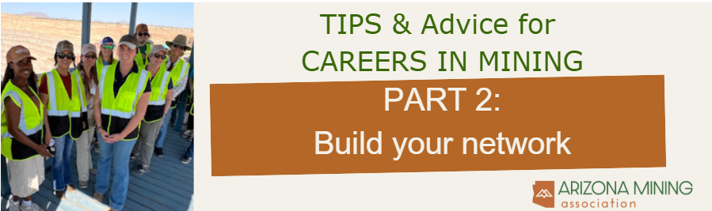
You’ve done your research and mining seems like a great fit. So now you just apply, right? Well — yes and no. These roles often attract a lot of interest, so standing out is key. A strong resume that clearly shows your relevant experience definitely helps (we’ve included an example to get you started). But sometimes, having a connection at the company — someone who can vouch for your interest or give you insight into the role — can really make a difference.

Networking: building and maintaining relationships with people in a professional or career context. It's not about asking for favors or trying to "get ahead" — it's about connecting with others in your field, sharing knowledge, and sometimes opening doors to new opportunities.

Before diving in, take some time to explore online and ask your teachers for guidance. In the meantime, here are a few tips to get you started.

Do you know someone in mining? Here are conversation starters to learn about the industry.
- How did you get started in mining and why do you like it?
- Did you go to school or receive on the job training for that role?
- Are there entry level jobs available at your company for someone like myself?
- May I use you as a reference?
- Do you recommend that I speak to someone about roles in mining or at your company?
- May I add you on LinkedIn? (If they leave their job, there is still a way to contact them. Research do’s and don’ts of how to foster your network and not burn them out. Be sure to include a note when adding.)

How to meet someone in mining and maintain the connection
- Ask your teacher about a guest speaker from mining. Afterward, ask the guest speaker if you may contact them to talk more about the industry.
- Look for mining events taking place near you. Attend the event and use the questions above to start talking with a representative.
- Research university clubs for mining. Reach out to the leadership and ask to talk to a student about their experience. Invite them to present in the classroom.
- Request 15-minute informational interview with a recruiter. Search online what general questions should be asked.
- Send a follow-up email or note to a contact that helped you, thanking them for their time.
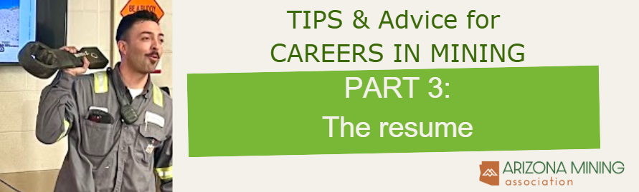

Here are instructions in how to use the following resume template:

- Replace all placeholder text with your own information — don’t leave sample content in your resume.
- Use easy-to-read fonts like Arial or Times New Roman. These are also best for compatibility with application systems.
- Keep your resume to one page. Recruiters often spend just 5–7 seconds scanning each resume.
- Remove any sections (like Certifications) if you don’t have anything to list under them.
- List experience in reverse chronological order.
- Use keywords from the job description. These are important words or phrases that highlight skills and experience the employer is looking for. Try to naturally include them in your resume.
- Write bullet points that show achievements, not just duties. What did you do well? What were the results? Use only 3-5 bullet points.
- No official job experience? That’s okay! Think about tasks you’ve done for neighbors or family — babysitting, landscaping, dog walking, pet sitting, house sitting — they all count.
- Highlight leadership and teamwork. Participation in sports, clubs, volunteer work, or school groups shows valuable skills. Think about how those roles connect to the job and be ready to talk about them in an interview.

Ask your school counselor and teachers for help and to proofread your cover letter and resume.

First Name Last Name
City, State | (480)-290-xxxx | email@gmail.com

CERTIFICATIONS

3G SMAW Certification, May 2025

OSHA Certification, September 2024

EDUCATION

3G SMAW Certification, May 2025
East Valley Institute of Technology, Mesa AZ

KEY SKILLS

Safety conscious, comfortable working in industrial environments

Team player that is hardworking, adaptable and coachable

Good communicator

EXPERIENCE

Crew Member August 2024 - Current

Raising Cane’s Chicken Fingers, Tempe, AZ
- Work in multiple roles with clear understanding of the stages of the process
- Use developed communication skills to maintain a positive guest experience during high-volume periods
- Reinforce food and workplace safety

Babysitter June 2020 - July 2024

Self-Employed, Tucson, AZ
- Took care of up to 2 children, ages 0-11
- Organized schedules, meals, and sleep schedules
- Maintained a safe environment for children by locking doors, being aware of potential hazards and monitoring the children at all times

LEADERSHIP ROLES, ACTIVITIES, AND AWARDS
Student of the month, 2025; Player of the year for Duo Cup Football, 2025

